The American University in Cairo
Engineering Department

MENG 453: Finite Element Method and Applications in Design
Fall 2001

Lab Session 2

Model and Analyze the shown 2D square plate with a hole

Material Properties
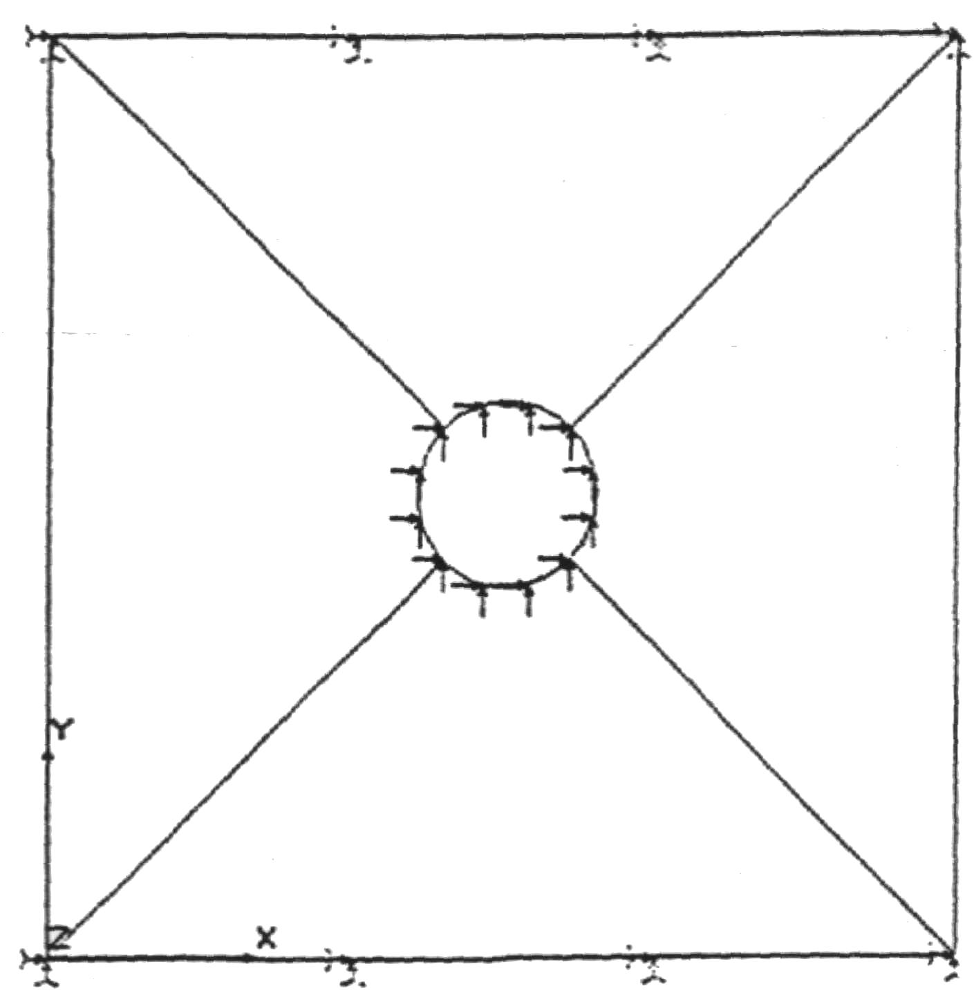
E=20 x 10⁶lb/in²
ν=0.3

Physical Properties (Real Constants)
Thickness: 0.2in

Constraints:
Clamp on upper and lower edges

Forces:
X-direction: 1000 lbs on each node on the inner circle
Y-direction: 1000 lbs on each node on the inner circle

